INDEX:

WEEK – 1 2

* Static Web pages: 6
* Dynamic Web Pages: 6

WEEK – 2 8

* Native apps: 8
* Web Apps: 9
* Various types of Tags: 9

WEEK-3 12

* Lists: 12
* Unordered List 13

Week – 4 20

* Frameset 20
* Attributes in Frameset 20

WEEK – 5 24

* Tables: 24

**WEB PROGRAMMING**

**1.What is web programming?**

->Web programming refers to the writing, markup and coding involved in Web development, which includes Web content, Web client and server scripting and network security. The most common languages used for Web programming are XML, HTML, JavaScript, Perl 5 and PHP. Web programming is different from just programming, which requires interdisciplinary knowledge on the application area, client and server scripting, and database technology.

-> To improve user experience and related functionalities on the client side, JavaScript is usually used. It is an excellent client-side platform for designing and implementing Web applications.

-> HTML5 and CSS3 supports most of the client-side functionality provided by other application frameworks.

**2.what is full form of HTML ? and what is its version?**

-> HYPER TEXT MARKUP LANGUAGE .

-> current version is HTML5

**3.How do we write code in HTML?**

<!DOCTYPE html>

<html>

<body>

<h1>My First Heading</h1>

<p>My first paragraph.</p>

</body>

</html>

**4.Difference b/w LAN,MAN & VAN**

-> A LAN (local area network) is a group of computers and network devices connected together, usually within the same building.

-> A MAN (metropolitan area network) is a larger network that usually spans several buildings in the same city or town.

-> A WAN (wide area network), in comparison to a MAN, is not restricted to a geographical location, although it might be confined within the bounds of a state or country. A WAN connects several LANs, and may be limited to an enterprise (a corporation or an organization) or accessible to the public. The technology is high speed and relatively expensive. The Internet is an example of a worldwide public WAN.

**5. Difference between physical address and logical address**

-> The logical address is a virtual address and can be viewed by the user. ... The fundamental difference between logical and physical address is that logical address is generated by CPU during a program execution whereas, the physical address refers to a location in the memory unit.

**6.What are h1-h6 tags in HTML?**

<!DOCTYPE html>

<html>

<body>

<h1>Heading 1</h1>

<h2>Heading 2</h2>

<h3>Heading 3</h3>

<h4>Heading 4</h4>

<h5>Heading 5</h5>

<h6>Heading 6</h6>

</body>

</html>

**OUTPUT :**

# **Heading 1**

## **Heading 2**

### **Heading 3**

#### **Heading 4**

##### **Heading 5**

###### **Heading 6**

**7. How many types of tags are there in HTML and what are they ?**

**1. Paired and Unpaired Tags**

**Paired Tags** : <p> This text is a paragraph . </p>

**Unpaired Tags :**

<p> This is a paragraph </p>

<hr>

<i> <b> This is a bold and italicized text </b> </i>

**2. Self-Closing Tags**

<img src="a.jpg" alt="This is an alternate text">

**3. Utility-Based Tags**

-> This is done using tags like <font>, <b>, <u>, etc. Tables, divisions, and span tags are also those tags that help format a web page or document and set the layout of the page.

**Control Tags**

Another category of tags that can be created is ‘Control Tags’. The Script tags, radio buttons or checkboxes, the Form tags, etc., forms the control tags

**8. what is a web page and what are the different types of web pages?**

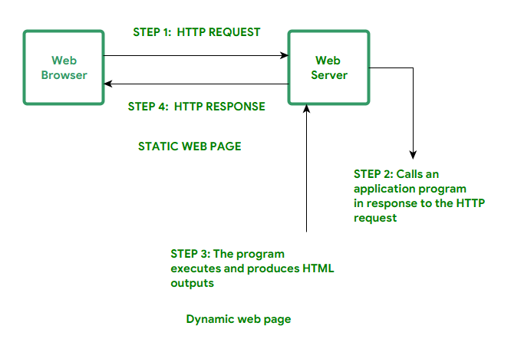

web page is a document available on world wide web. Web Pages are stored on web server and can be viewed using a web browser. A web page can cotain huge information including text, graphics, audio, video and hyper links. These hyper links are the link to other web pages

**-> Static Web pages:**

Static Web pages are very simple. It is written in languages such as HTML, JavaScript, CSS, etc. For static web pages when a server receives a request for a web page, then the server sends the response to the client without doing any additional process. And these web pages are seen through a web browser. In static web pages, Pages will remain the same until someone changes it manually.

**-> Dynamic Web Pages:**

Dynamic Web Pages are written in languages such as CGI, AJAX, ASP, ASP.NET, etc. In dynamic web pages, the Content of pages is different for different visitors. It takes more time to load than the static web page. Dynamic web pages are used where the information is changed frequently, for example, stock prices, weather information, etc.

**9.what is a website ?**

A website is a collection of web pages and related content that is identified by a common domain name and published on at least one web server. Notable examples are wikipedia.org, google.com, and amazon.com. All publicly accessible websites collectively constitute the World Wide Web

**WEEK – 2**

**1.** **what is the difference between head title and body in html**

**HTML Head**

Head is the first part of the HTML document that is used to add additional information to the HTML document.

Head contains meta information, the title of the page, internal style, external stylesheet link, internal javascript, external JavaScript file linking, etc.

The head is not required to be present in the document, but it is recommended to be present.

There should only be one head in an HTML document.

The Head is a block of information that is placed at the top of the document.

The head is the first section of the document and contains information that is shared by all the pages in the document.

**HTML Body**

Body is the part of HTML that contains the content of the page. The body section is the second section of the HTML document where the first section is head.

Everything that you see, read or hear on a browser lies in the body of HTML, like text, images, GIFs, videos, audios, etc.

**2.what is the difference between mobile application and web application**

**Native Apps:**

Native apps are installed onto the device itself and are developed especially for a particular mobile operating system. These apps are available on app stores such as Apple App Store, Google Play Store, etc.

Native apps work in specific mobile operating systems such as Apple iOS or Android OS. If an app made for Android OS then it will not work on Apple iOS or Windows OS. We have to build separate apps for each operating system if we want to work our app across all major operating systems. This means we have to spend more money and more effort (time, resources).

**Web Apps:**

Web Apps can be accessed through the mobile device’s Web browser, Web Apps are based on internet-enabled applications. In order to access we don’t need to download and install the app onto a mobile device.

The app is developed as web pages in HTML and CSS, interactive parts are developed in JQuery, JavaScript, or similar language. The single web app can be used on most devices capable of surfing the web, it does not depend upon the operating system they use.

**3. various cateograies of tags in html**

The HTML tags can also be simply divided based on basic categories like **Basic HTML Root Tags, Formatting tags, Audio and Video Tags, Form and Input Tags, Frame Tags, Link Tags, List Tags, Table Tags, Style Tags, Meta Tags**, etc.

**1. Paired and Unpaired Tags**

**Paired Tags** : <p> This text is a paragraph . </p>

**Unpaired Tags :**

<p> This is a paragraph </p>

<hr>

<i> <b> This is a bold and italicized text </b> </i>

**2. Self-Closing Tags**

<img src="a.jpg" alt="This is an alternate text">

**3. Utility-Based Tags**

-> This is done using tags like <font>, <b>, <u>, etc. Tables, divisions, and span tags are also those tags that help format a web page or document and set the layout of the page.

**Control Tags**

Another category of tags that can be created is ‘Control Tags’. The Script tags, radio buttons or checkboxes, the Form tags, etc., forms the control tags

**OUTPUT :**



**WEEK-3**

There are 2 types of lists and they are:

* Ordered Lists
* Unordered Lists

**Ordered Lists:**

* An ordered list starts with the <ol> tag. Each list item starts with the <li> tag.The list items will be marked with numbers by default.
* The HTML <ol> tag defines an ordered list. An ordered list can be numerical or alphabetical.

**Type attributes in Ordered list:**

The type attribute of the <ol> tag, defines the type of the list item marker:

|  |  |
| --- | --- |
| **Type** | **Description** |
| type="1" | The list items will be numbered with numbers (default) |
| type="A" | The list items will be numbered with uppercase letters |
| type="a" | The list items will be numbered with lowercase letters |
| type="I" | The list items will be numbered with uppercase roman numbers |
| type="i" | The list items will be numbered with lowercase roman numbers |

**Syntax: (ordered list)**

<ol type=””>

<li>………………………………….</li>

<li> …………………………………..</li>

<li>………………………………….</li>

<ol>

* Use the HTML <ol> element to define an ordered list
* Use the HTML type attribute to define the numbering type
* Use the HTML <li> element to define a list item
* Lists can be nested
* List items can contain other HTML elements

**Unordered List:**

* An unordered list starts with the <ul> tag. Each list item starts with the <li> tag.
* The list items will be marked with bullets (small black circles) by default
* The HTML <ul> tag defines an unordered (bulleted) list.

**Type attributes in unordered lists:**

* The type attribute of the <ul> tag, defines the type of the list item marker:

|  |  |
| --- | --- |
| **Value** | **Description** |
| disc | Sets the list item marker to a bullet (default) |
| circle | Sets the list item marker to a circle |
| square | Sets the list item marker to a square |
| none | The list items will not be marked |

**Unordered lists syntax:**

<ul type=””>

<li>……………………………….</li>

<li>………………………………..</li>

<li>…………………………………</li>

<ul>

**Video Tag:**

The <video> tag is used to embed video content in a document, such as a movie clip or other video streams.

The <video> tag contains one or more [<source>](https://www.w3schools.com/tags/tag_source.asp) tags with different video sources. The browser will choose the first source it supports.

The text between the <video> and </video> tags will only be displayed in browsers that do not support the <video> element.

There are three supported video formats in HTML: MP4, WebM, and OGG.

**Attributes in video tag:**

|  |  |  |
| --- | --- | --- |
| **Attribute** | **Value** | **Description** |
| [autoplay](https://www.w3schools.com/tags/att_video_autoplay.asp) | autoplay | Specifies that the video will start playing as soon as it is ready |
| [controls](https://www.w3schools.com/tags/att_video_controls.asp) | controls | Specifies that video controls should be displayed (such as a play/pause button etc). |
| [height](https://www.w3schools.com/tags/att_video_height.asp) | *pixels* | Sets the height of the video player |
| [loop](https://www.w3schools.com/tags/att_video_loop.asp) | loop | Specifies that the video will start over again, every time it is finished |
| [muted](https://www.w3schools.com/tags/att_video_muted.asp) | muted | Specifies that the audio output of the video should be muted |
| [poster](https://www.w3schools.com/tags/att_video_poster.asp) | *URL* | Specifies an image to be shown while the video is downloading, or until the user hits the play button |
| [preload](https://www.w3schools.com/tags/att_video_preload.asp) | auto metadata none | Specifies if and how the author thinks the video should be loaded when the page loads |
| [src](https://www.w3schools.com/tags/att_video_src.asp) | *URL* | Specifies the URL of the video file |
| [width](https://www.w3schools.com/tags/att_video_width.asp) | *pixels* | Sets the width of the video player |

**Syntax for Video tag:**

<video width = “ “ height = “ ” poster = “.png/.jpeg/url“ controls>

<source src = “url or path of file.mp4” type = “video/mp4”>

(or)

<source src = “url or path of file.ogg” type = “video/ogg”>

</video>

**Audio Tag:**

The <audio> tag is used to embed sound content in a document, such as music or other audio streams.

The <audio> tag contains one or more [<source>](https://www.w3schools.com/tags/tag_source.asp) tags with different audio sources. The browser will choose the first source it supports.

The text between the <audio> and </audio> tags will only be displayed in browsers that do not support the <audio> element.

There are three supported audio formats in HTML: MP3, WAV, and OGG.

**Attributes in Audio tag:**

|  |  |  |
| --- | --- | --- |
| **Attribute** | **Value** | **Description** |
| [autoplay](https://www.w3schools.com/tags/att_audio_autoplay.asp) | autoplay | Specifies that the audio will start playing as soon as it is ready |
| [controls](https://www.w3schools.com/tags/att_audio_controls.asp) | controls | Specifies that audio controls should be displayed (such as a play/pause button etc) |
| [loop](https://www.w3schools.com/tags/att_audio_loop.asp) | loop | Specifies that the audio will start over again, every time it is finished |
| [muted](https://www.w3schools.com/tags/att_audio_muted.asp) | muted | Specifies that the audio output should be muted |
| [preload](https://www.w3schools.com/tags/att_audio_preload.asp) | auto metadata none | Specifies if and how the author thinks the audio should be loaded when the page loads |
| [src](https://www.w3schools.com/tags/att_audio_src.asp) | *URL* | Specifies the URL of the audio file |

**Syntax for Audio Tag:**

<audio controls>

<source src = “url or path of file.mp3” type = “audio/mpeg”>

(or)

<source src = “url or path of file.ogg” type = “audio/ogg”></audio>

**OUTPUT :**

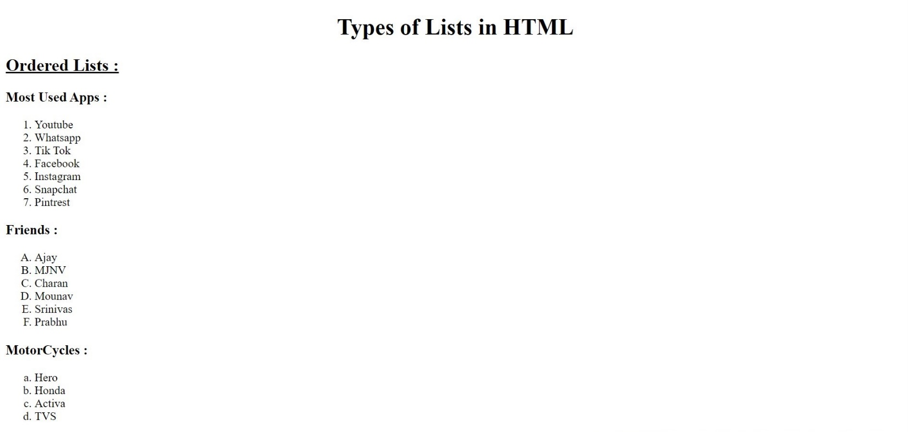

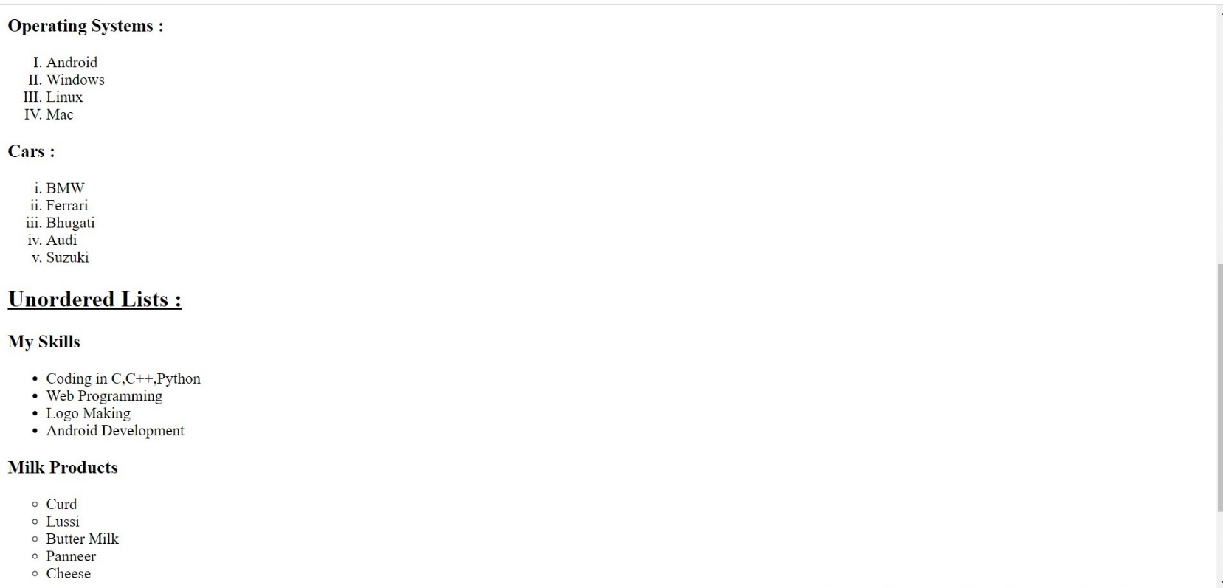



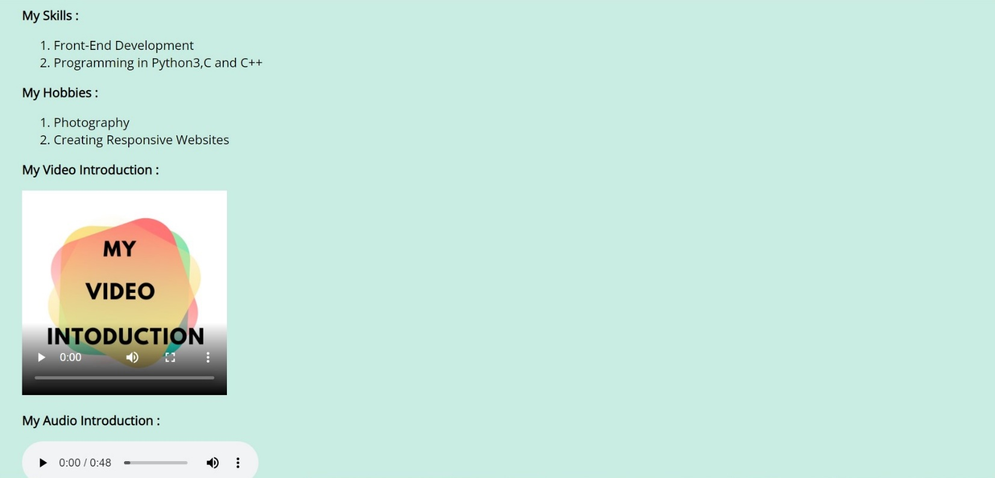

**WEEK - 4**

**Frameset:**

The <frameset> tag in HTML is used to define the frameset. The <frameset> element contains one or more frame elements. It is used to specify the number of rows and columns in frameset with their pixel of spaces. Each element can hold a separate document.

HTML frames are used to divide your browser window into multiple sections where each section can load a separate HTML document. A collection of frames in the browser window is known as a frameset. The window is divided into frames in a similar way the tables are organized: into rows and columns.

**Attributes in Frameset:**

**cols**: The cols attribute is used to create vertical frames in a web browser. This attribute is basically used to define the no. of columns and their size inside the frameset tag.

**rows:** The rows attribute is used to create horizontal frames in the web browser. This attribute is used to define the no. of rows and their size inside the frameset tag.

**border:** This attribute of frameset tag defines the width of the border of each frame in pixels. Zero value is used for no border.

**frameborder:** This attribute of frameset tag is used to specify whether a three-dimensional border should be displayed between the frames or not for this use two values 0 and 1, where 0 defines no border and value 1 signifies for yes there will be a border.

**framespacing:** This attribute of frameset tag is used to specify the amount of spacing between the frames in a frameset. This can take any integer value as a parameter which basically denotes the value in pixel.

**Syantax For Column’s Division:**

<frameset cols = “n1%, n2%, n3%>

<frame name = “top” src = “first file.html” />

<frame name = “main” src = “second file.html” />

<frame name = “bottom” src = “third file.html” />

.

.

.

.

<noframes>

<body>

You can write here documentation.

n1,n2,n3 are the division of web-page percentages.

</body>

</noframes>

</frameset>

**Syantax For Row’s Division:**

<frameset rows = “n1%, n2%, n3%>

<frame name = “top” src = “first file.html” />

<frame name = “main” src = “second file.html” />

<frame name = “bottom” src = “third file.html” />

.

.

.

.

<noframes>

<body>

You can write here documentation.

n1,n2,n3 are the division of web-page percentages.

</body>

</noframes>

</frameset>

**OUTPUT :**

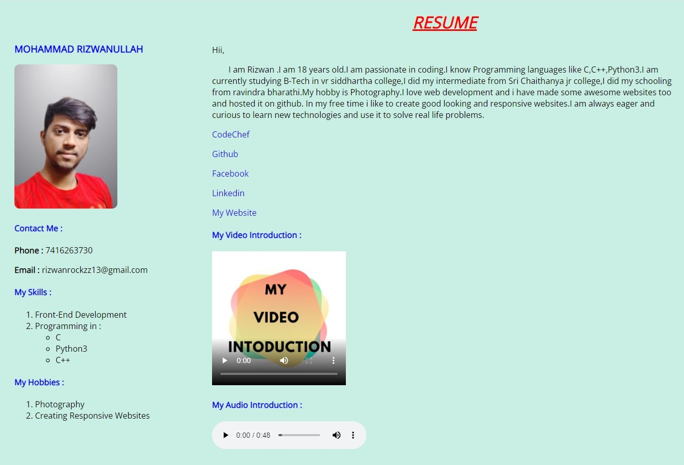

**WEEK-5**

* HTML tables allow web developers to arrange data into rows and columns.
* The HTML tables are created using the **<table>** tag in which the **<tr>** tag is used to create table rows and **<td>** tag is used to create data cells. The elements under <td> are regular and left aligned by default

**Table Heading:**

* Table heading can be defined using **<th>** tag. This tag will be put to replace <td> tag, which is used to represent actual data cell. Normally you will put your top row as table heading as shown below, otherwise you can use <th> element in any row. Headings, which are defined in <th> tag are centered and bold by default.

|  |  |
| --- | --- |
| **Tag** | **Description** |
| [<table>](https://www.w3schools.com/tags/tag_table.asp) | Defines a table |
| [<th>](https://www.w3schools.com/tags/tag_th.asp) | Defines a header cell in a table |
| [<tr>](https://www.w3schools.com/tags/tag_tr.asp) | Defines a row in a table |
| [<td>](https://www.w3schools.com/tags/tag_td.asp) | Defines a cell in a table |

|  |  |
| --- | --- |
| [<caption>](https://www.w3schools.com/tags/tag_caption.asp) | Defines a table caption |
| [<colgroup>](https://www.w3schools.com/tags/tag_colgroup.asp) | Specifies a group of one or more columns in a table for formatting |
| [<col>](https://www.w3schools.com/tags/tag_col.asp) | Specifies column properties for each column within a <colgroup> element |
| [<thead>](https://www.w3schools.com/tags/tag_thead.asp) | Groups the header content in a table |
| [<tbody>](https://www.w3schools.com/tags/tag_tbody.asp) | Groups the body content in a table |
| [<tfoot>](https://www.w3schools.com/tags/tag_tfoot.asp) | Groups the footer content in a table |

**OUTPUT :**



